1)Radio button - To work radio buttons as one, give them common name
<form>
<input type="radio" name="gender" value="male" checked> Male<br>
<input type="radio" name="gender" value="female"> Female<br>
<input type="radio" name="gender" value="other"> Other
</form>

2)For submit button , value attribute is name of the button
<input type="submit" value="Submit">

3)Anchor tag has target attribute which tells where to open the link
<a href="https://www.w3schools.com" target="_blank">Visit W3Schools</a>

Value | Description
_blank | Opens the linked document in a new window or tab
_self | Opens the linked document in the same frame as it was clicked (this is default)
_parent | Opens the linked document in the parent frame
_top | Opens the linked document in the full body of the window
framename | Opens the linked document in a named frame

4) iframes
<iframe src="https://www.w3schools.com">
<p>Your browser does not support iframes.</p>
</iframe>

5) attribute selector – eg -hidden attribute of button or target attribute of link
a[target] {
background-color: yellow;
}

6) Precedence Specifity cascading
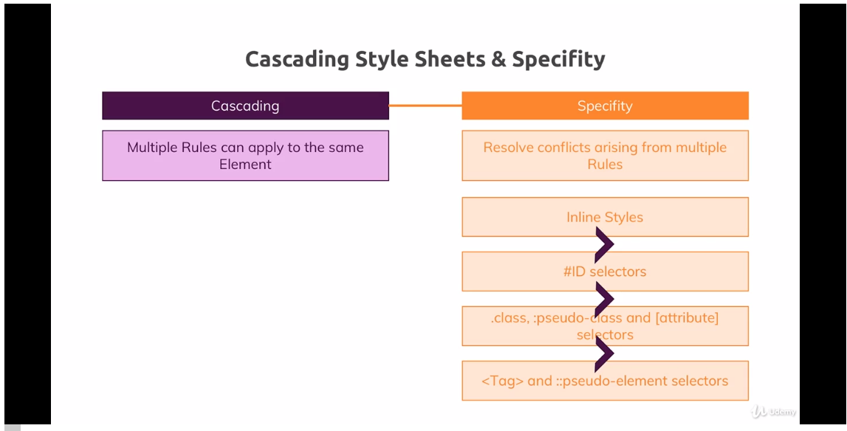

combinators has higher specificity as it is more specific
eg - header h1 – it means any h1 inside header tag
eg – header div h1 – here this one wins over previous one as it is more specific

combinators - ( Note that performance wise combinators are little slow )

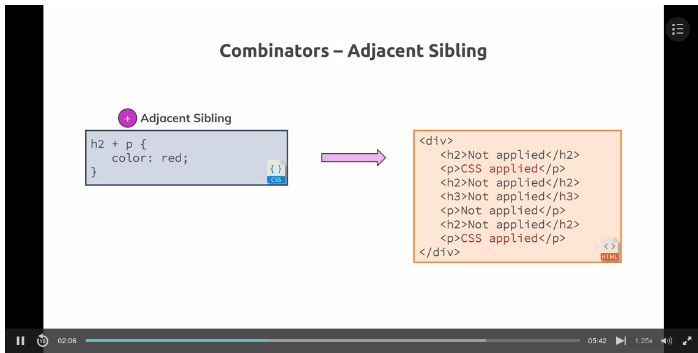

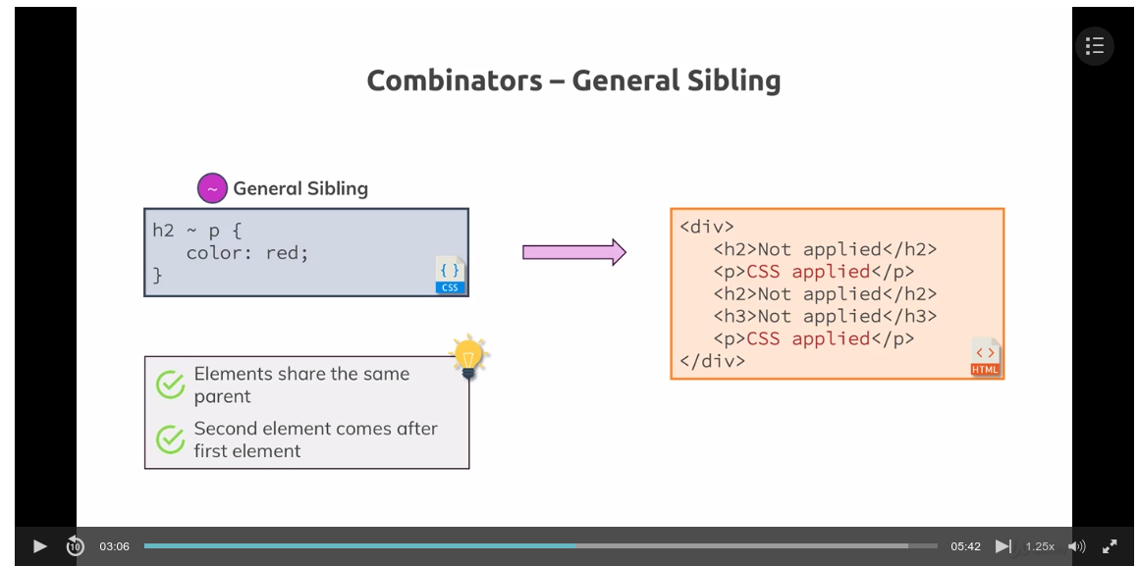

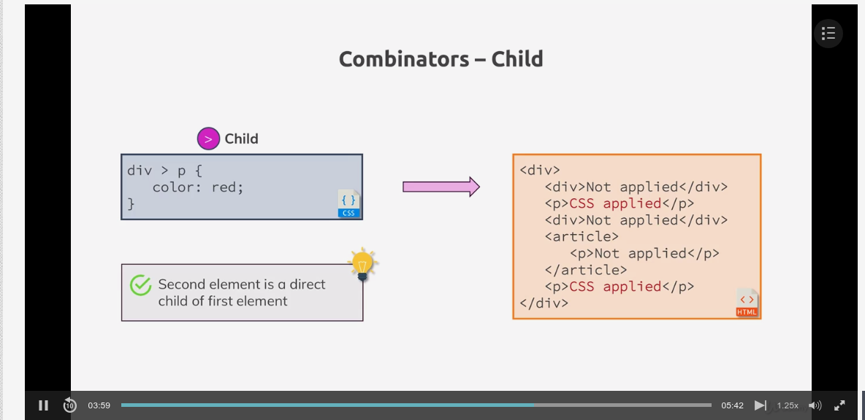

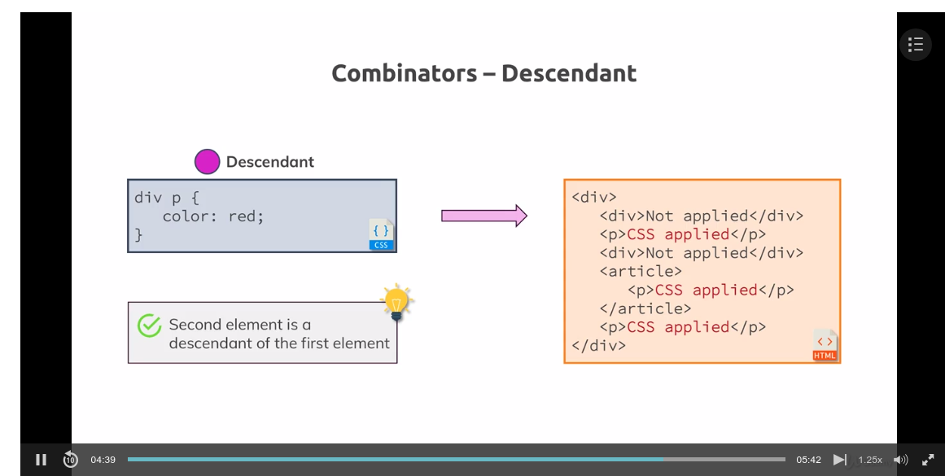

When applying common style to all page use “body” instead of “*” as body has high specifity

Inheritance -
body {
font-family: “roboto”;
}

here suppose we have h1 tag and we specify h1 to be san-serief, then san-serief style will be applied
but suppose if we have a p tag without styles then roboto style will be applied to it as it inherited it from body tag . This works with few styles like font weight, font family etc .

Case where universal selector is important

body {
box-sizing: border-box
}

here if we apply box-sizing to body then then inside div or any block element , it is not inherited as browser overrides block element to content-box
se we use universal selector to set box-sizing: border-box

6) Margin collapse

if above element has margin bottom of 20px and below element has margin top of 40 px then their margins will be collapsed and bigger margin wins

7) Inline block – using inline block causes unintentional spaces if we have space in our text editor

8 ) properties to remember -
vertical align
border-radius

9) sudo class and sudo element diff
sudo class allows us to style diff states of a class or item eg - :hover
sudo element allows us to style part of an element eg - ::first-letter

10) Suppose if a element has 2 class called class one and class two
and if
.one {
color: red
}

.two {
color: green
}

then green color will me applied because class two is defined last in css file if we move up two class then color red will be applied

